

SOFTWARE CONSTRUCTION AND DEVELOPMENT

(ASSIGNMENT)

BY

DIYA KUMARI(21SW032)

NOOR FATIMA(21SW062)

DUAA IRAJ(21SW068)

FARAH ALI(21SW144)

BUSINESS WEBSITE:

DESCRIPTION:

Welcome to our business website, which sells hoodies, jeans, and shoes! We are pleased to introduce our online platform, which is intended to meet your fashion needs. It is the result of the combined efforts of four committed individuals.Noor Fatima(21sw062),Duaa Iraj(21sw068),Diya ramwani(21sw032),Farah Ali(21sw144).We have developed four sections of this website Homepage, About, Services, and contact.In this project, Noor Fatima owns the central repository and rest are collaborators.

1.HOME PAGE:

Our home page, which Noor Fatima created, provides you with all the information you need to know about our company as well as easy links to our social media pages.



2.ABOUT PAGE:

The 'About' section has been created by Farah Ali. She provides valuable insights into our team, interests, and exceptional skills. Learn about our dedication to on-time delivery, a wide selection of products, awards, and 24/7 customer service.

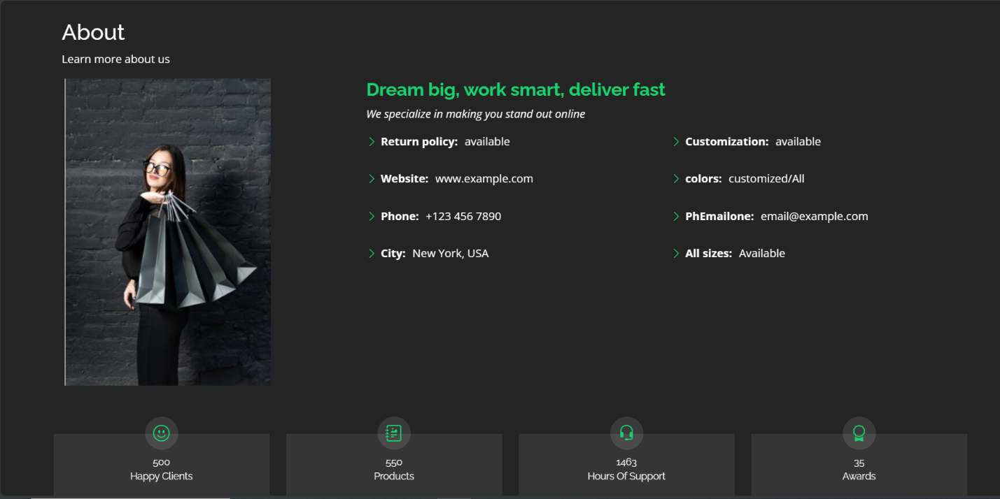

3.SERVICES PAGE:

Diya Ramwani created the 'Services' area, where eye-catching images highlight our wide range of shoes, hoodies, and jeans. On this page, she has added sections for all items, shoes, jeans, and hoodies.



4.CONTACT PAGE:

Finally, Duaa Iraj has created the 'Contact' page, which includes our phone number, email address, social media accounts, and address. Use our easy form to contact us with your thoughts and questions. At the bottom of the page, there is again our company's address and services along with some helpful links.

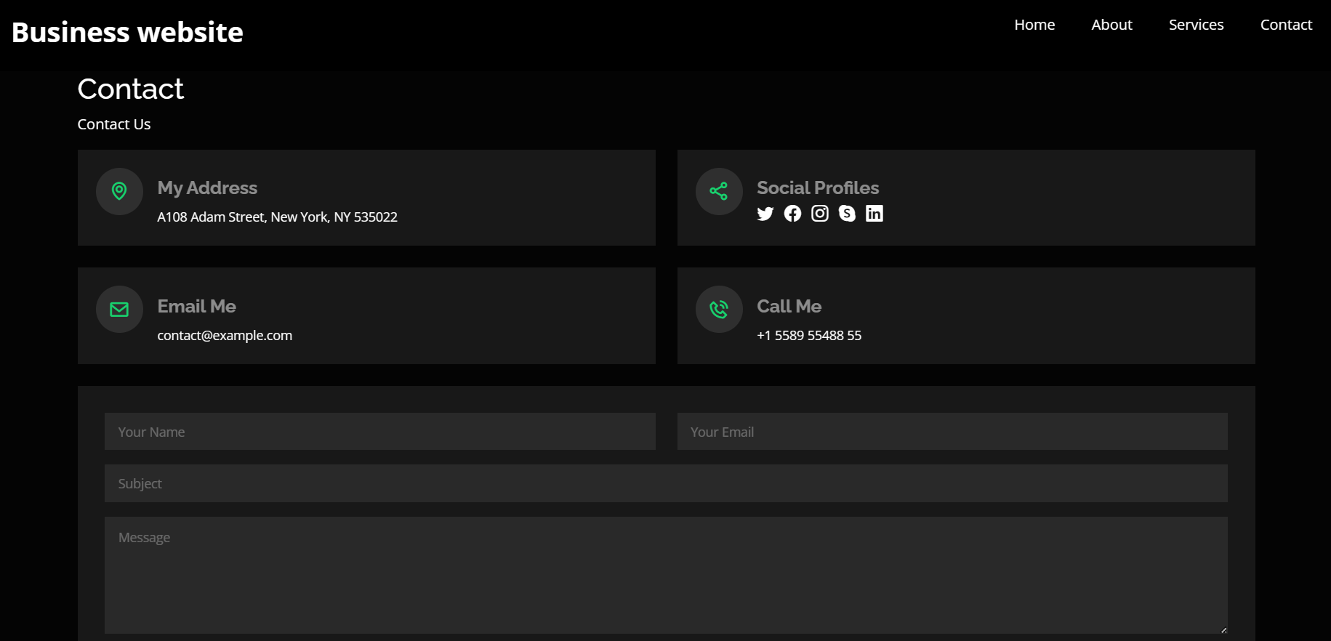

GIT CONFIG AND PULL CONCEPT:

First we set the global Git config for username and email. Then run the commands git config --global user.name "Duaa Iraj" and git config --global user.email "duaairaj14@gmail.com". This configures Git to identify the user by this name and email whenever they commit changes.

The git status command tells you the current state of the Git repository. The output shows that the user is on the branch named “contact-page” and there are uncommitted changes to the files “contact.html” and “assets/css/contact.css.css”.

the command git add adds all the changed files in the working directory to the staging area. The staging area is a collection of files that are ready to be committed in your next Git commit.

the command git commit -m "Contact page is ready". This commits the changes that were staged in the previous step with the message “Contact page is ready”

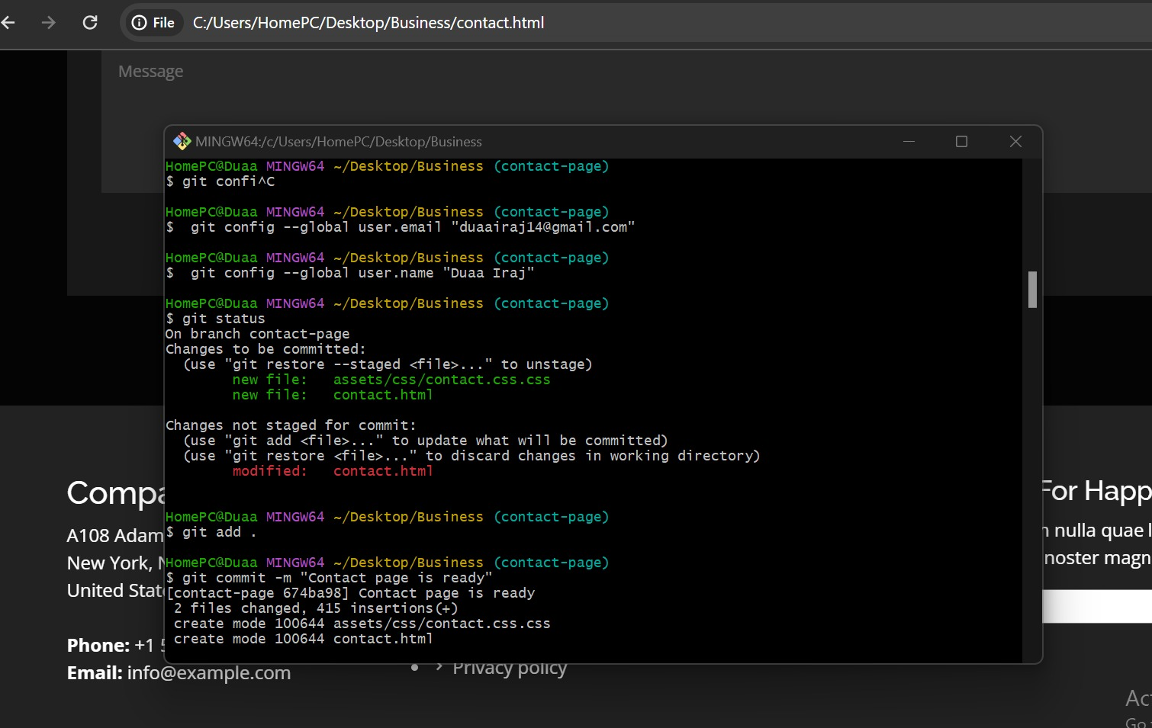

STASHING CONCEPT:

The git stash command temporarily saves the current state of your working directory and index. This can be useful if you're working on something but need to switch to another task and don't want to commit your current changes.

The output of the git stash command shows that the stash was successful and includes a reference number and a description of the stash. In this case, the description is "WIP on contact-page: 4470229 Connecting the different pages.

Switching to the branch named "main" using the git checkout main command,switching back to the branch named "contact-page" using the git checkout contact-page command.

The git stash list command shows information about all the stashes that have been created.

The output of the git stash list command shows there is one stash, which matches the stash created earlier.

The git stash pop command applies the most recent stash to the working directory.

The output of the git stash pop command shows that the stash was successfully applied, the changes from the stash are now in the working directory and the stash has been removed.

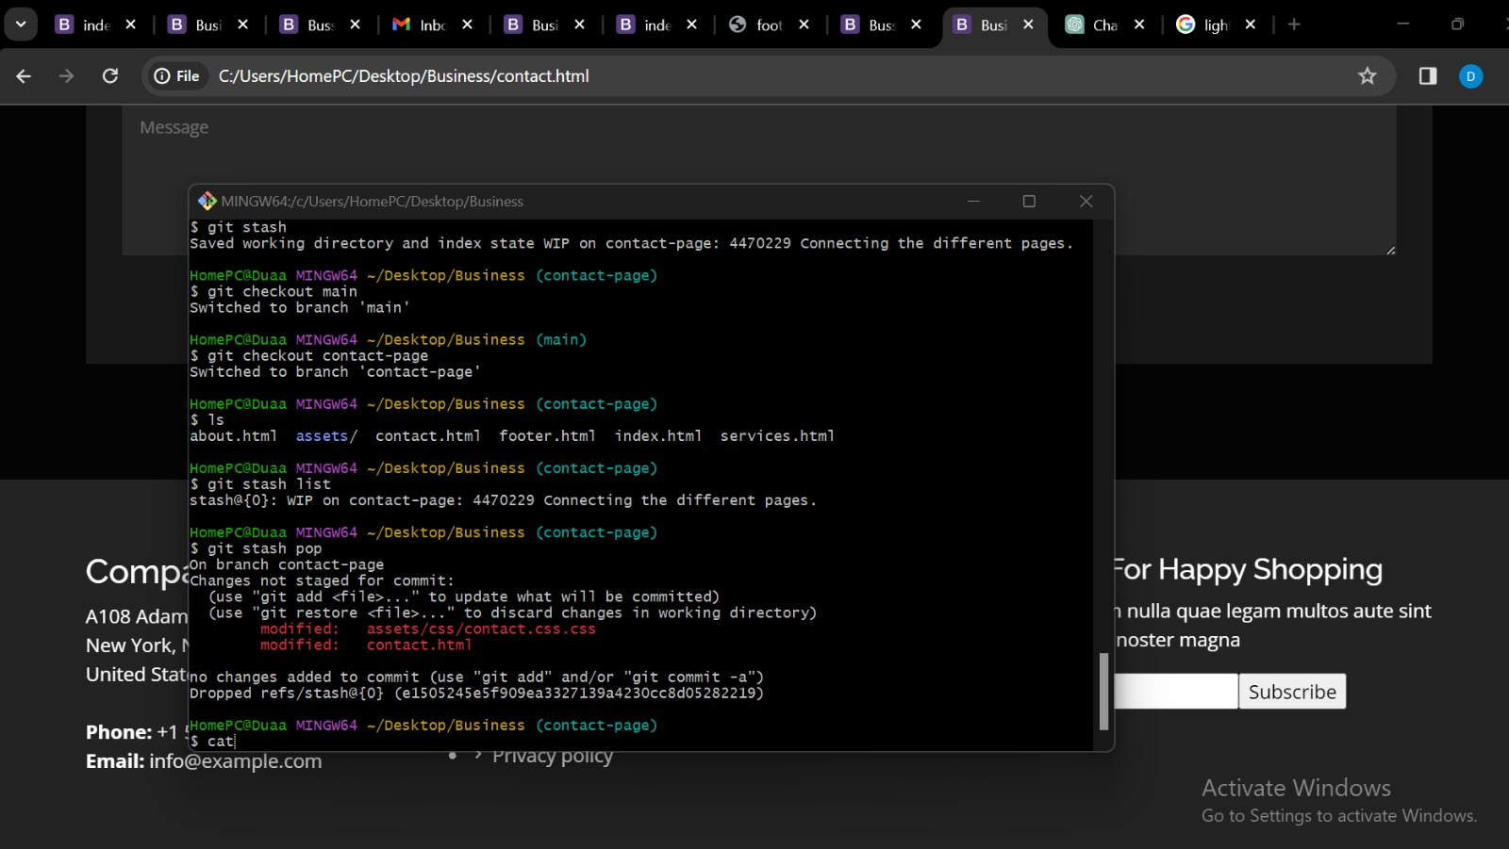

GITIGNORE CONCEPT:

The command 5 nano .gitignore. The nano command is a text editor commonly used on Linux and Unix-based systems. The . refers to the current directory and .gitignore is the filename. So, this command is opening a file named .gitignore for editing in the nano text editor.

The contents of the .gitignore file are not visible,because nano is a text-based editor and doesn't show up in screenshots. A .gitignore file is used to specify files and patterns that Git should ignore. This can be useful for files that you don't want to track in your Git repository, such as files that contain sensitive information or files that are automatically generated by your computer.

The git status command tells you the current state of the Git repository. The output shows that the user is on the branch named “main” and there is a new file named “.gitignore” that is not yet staged.

The command git add .gitignore This command adds the new .gitignore file to the staging area. The staging area is a collection of files that are ready to be committed in your next Git commit.

The command git commit -m "added .gitignore". This commits the changes that were staged in the previous step with the message “added .gitignore”.

